EL 2003 Comp Org & Assembly Language Lab

LABORATORY MANUAL ⦁Fall 2022⦁Instructor: Rukhsar Ali

|  |
| --- |
| **LAB 01** |
| **Configuration of VS2019** |



|  |  |  |  |  |
| --- | --- | --- | --- | --- |
|  | | | | |
|  | | | | |
|  | | | | |
|  | |  | |  |
| ________________________________________ | | __________ | | ___ |
| STUDENT NAME | | ROLL NO | | SEC |
|  | | | | |
| ______________________________________ | | | | |
| SIGNATURE & DATE | | | | |
| **MARKS AWARDED: ______________** | | | | |
| ___________________________________________________________________ | | | | |
| **NATIONAL UNIVERSITY OF COMPUTER AND EMERGING SCIENCES (NUCES), KARACHI** | | | | |
|  | | | | |
| Prepared by: | Rukhsar Ali | Version:  Date: | 1.0  23rd Aug 2022 | |

**Lab Session 01: Configuration of VS2019**

**Objectives:**

* Introduction to Visual Studio 2019
* An introduction to Assembly Language
* Understanding the Visual Studio 2019
* Configuring Visual Studio 2019 to activate MASM assembler
* Running a test program

# **Section 1: Introduction to visual studio 2019**

Visual Studio (for all its versions) is an integrated development environment (IDE) from Microsoft. It is a leading tool to develop computer programs, as well as web sites, web applications and web services. For this course, we will use Visual Studio version 2019 to develop programs in Assembly Language. We could, however, use a stand-alone assembler like NASM or MASM to code in Assembly Language.

# **Installation Process**

Go to this link <https://visualstudio.microsoft.com/downloads/>and select VS 2019 Download for community version

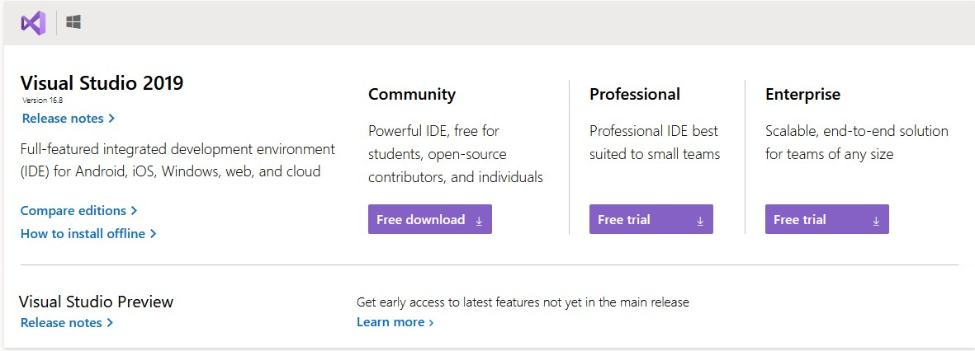

Run that downloaded setup on your system and when it’s complete, you have to download and install **Desktop Development with C++**. When it’s done you are ready to go.

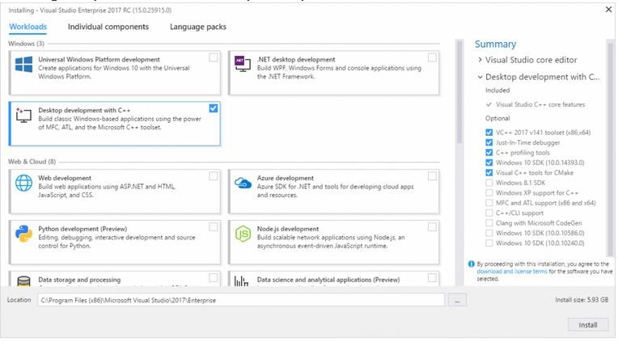

# **Configuration vs2019 for assembly language**

Click here to download Irvine library from this link:[www.asmirvine.com/gettingStartedVS2019/Irvine.zip](http://www.asmirvine.com/gettingStartedVS2019/Irvine.zip)

Once you have downloaded the required Irvine library, install it in your computer and verify that a folder named Irvine has been created in your C:\ drive. Now, follow these steps to configure Visual Studio 2019:

1. Start Microsoft Visual Studio 2019. If you are running it for the first time then this would be the screen you may see

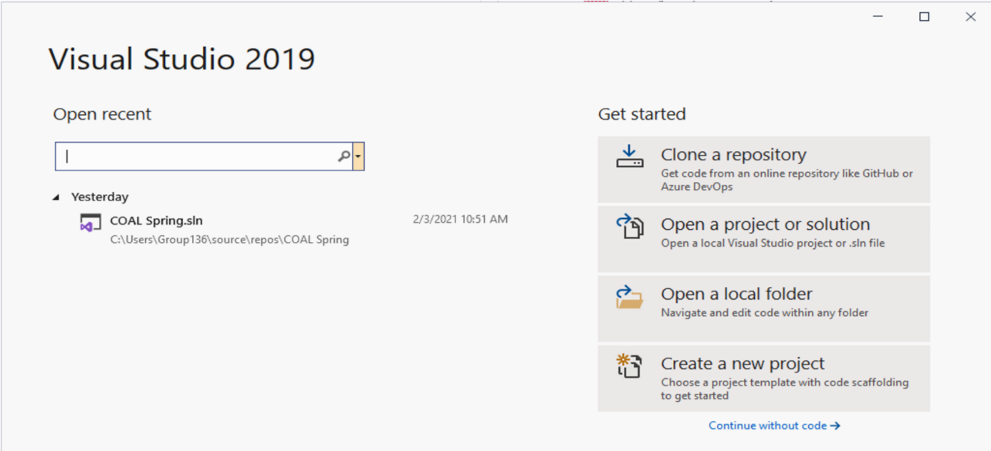

Select Create a new project.

1. From languages select **C++,** and then create an empty project

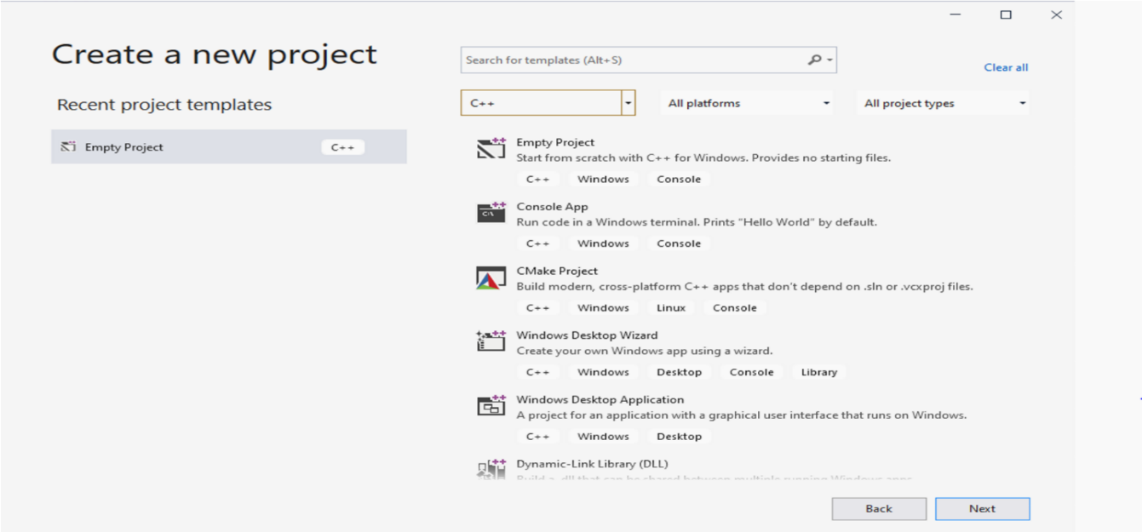

1. Once your new project is created, press **Ctrl+Alt+L** to open **Solution Explorer**. In the solution explorer window, you would see your project’s file hierarchy.

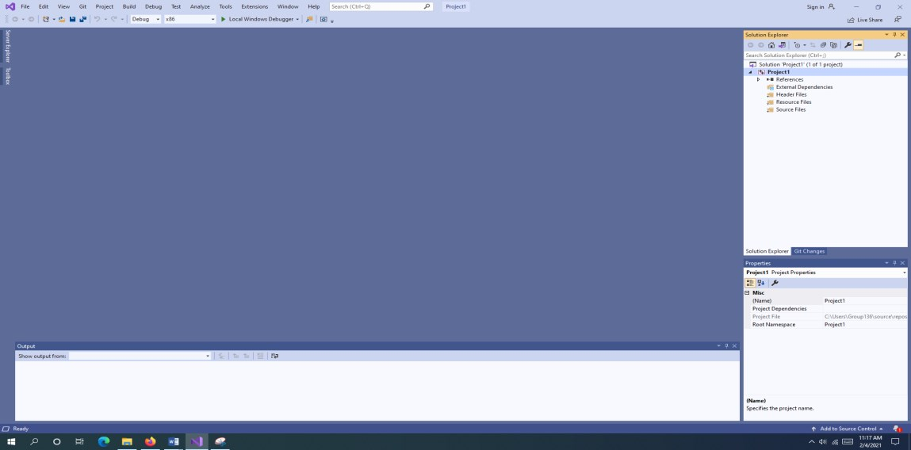

Now right click on your project. Go to **Build Dependencies** and then select **Build Customization**

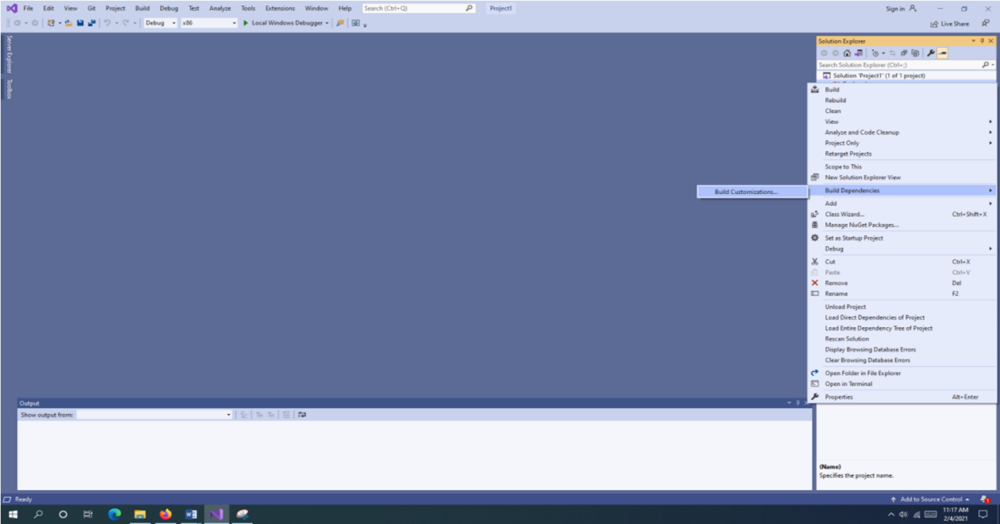

Tick the **masm** checkbox & select **OK**.

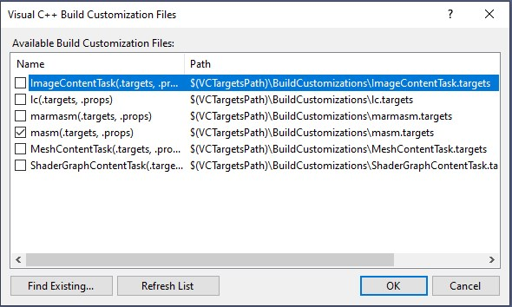

1. 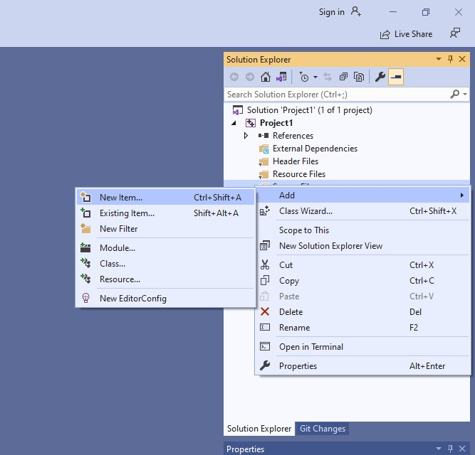 Right-click on **Source Files** in solution explorer & select **Add > New Item**.

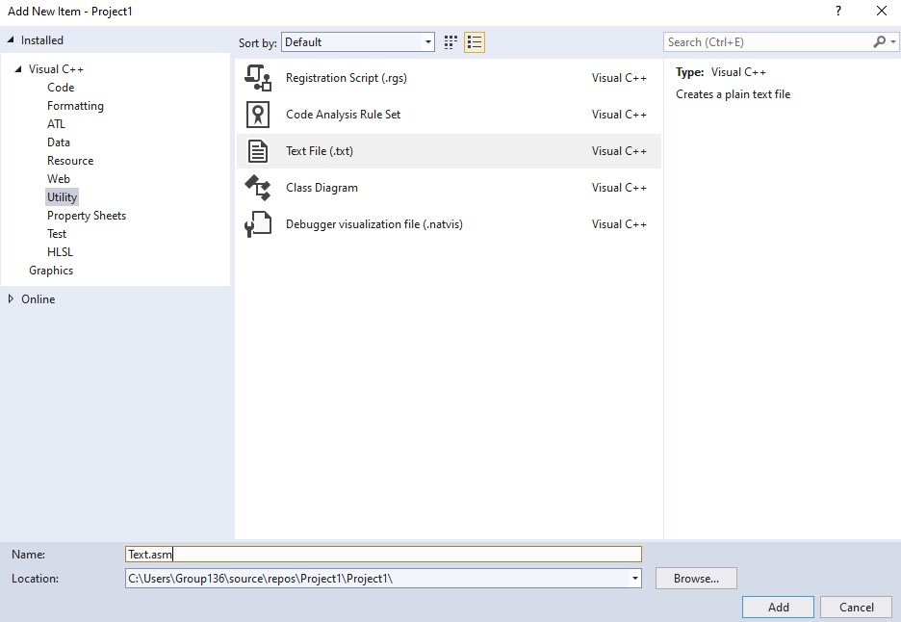Now go to **Utility > Text File** to add a new file, but we do not want to add .txt file, instead we want to add a .asm file. So, rename your new text file as Test.asm (we can choose any other name e.g. xyz.asm but for this tutorial we will use the name Test.asm).

1. Now right-click your project again and click **Properties**. Now click the tiny arrow marker besides **Configuration Properties** to expand it. Now click **Microsoft Macro Assembler** and expand it.

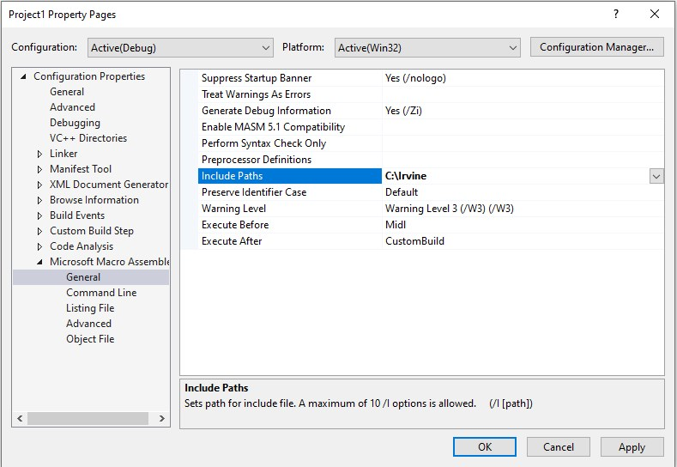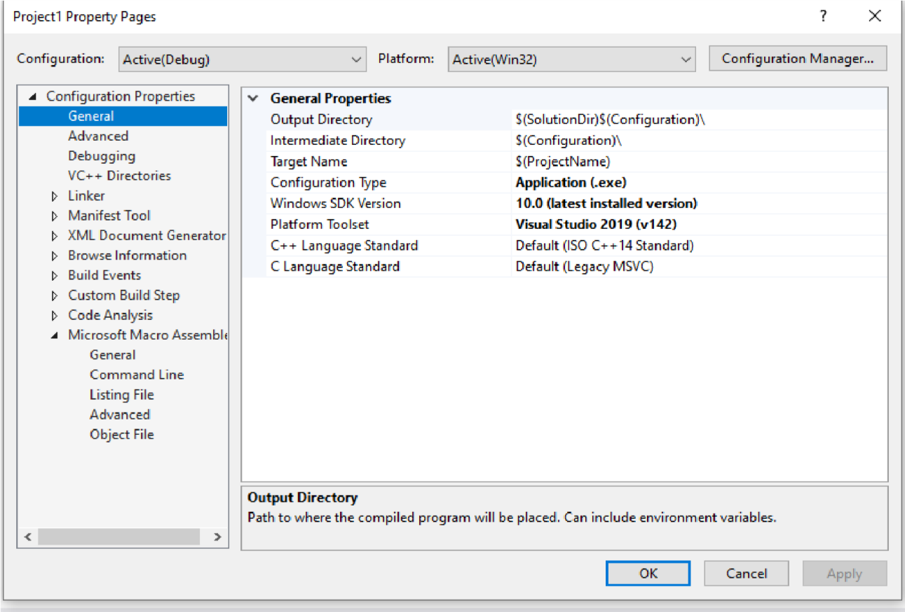

1. Now click **General** entry under Microsoft Macro Assembler and then set the value of **Include Paths** as **C:\Irvine**. The menu should now like this.
2. 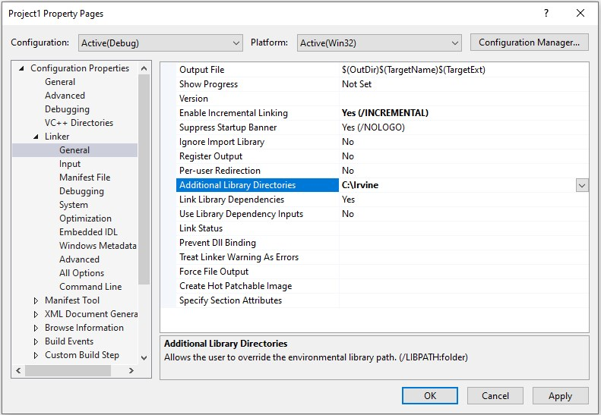Click **Linker** tab to expand it. Select **General** and set the value of **Additional Library Directories** to **C:\Irvine**
3. 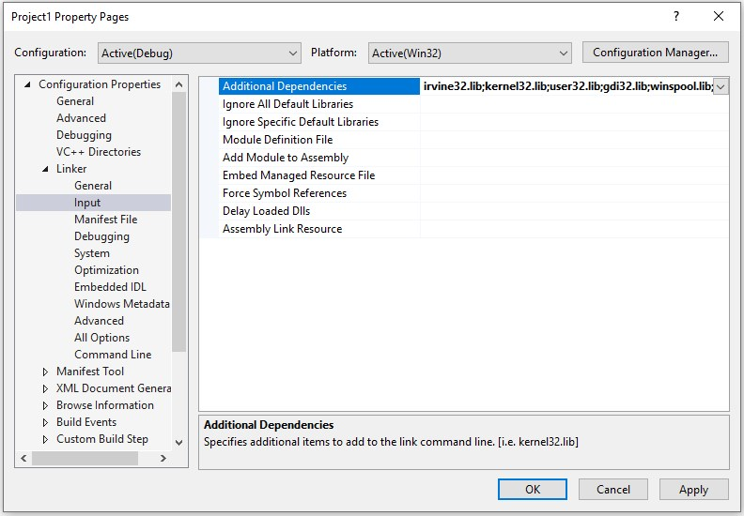Click **Input**, select **Additional Dependencies**. You will see a list of different .lib file names written there, do not alter any of those. Write **irvine32.lib;** at the start of the list like this.
4. Click Listing File. Select Assembled Code Listing File option and set its value as $AssemblyDemo.lst (we have written AssemblyDemo here. If you have given some other name to your project then it will be like $YourProjectName.lst).

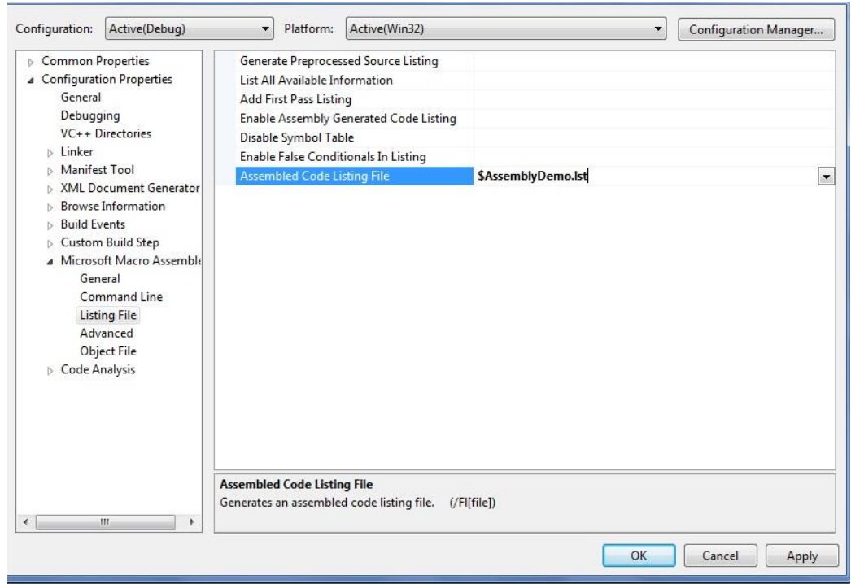

1. Click Debugging and make sure its Generate Debug Info option is set to Yes (/DEBUG).

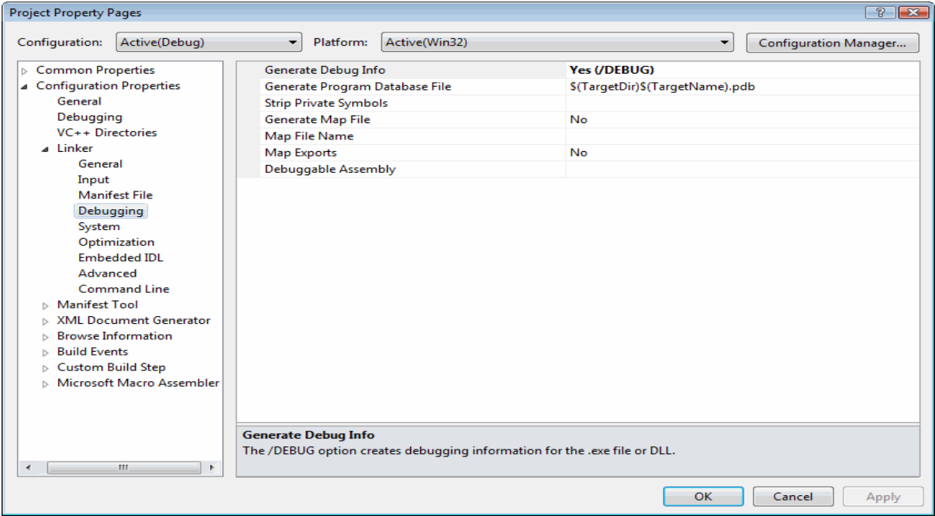

1. Click System, select SubSystem and set its value to Console (/SUBSYSTEM:CONSOLE). Now click Apply and OK to close the Properties window.

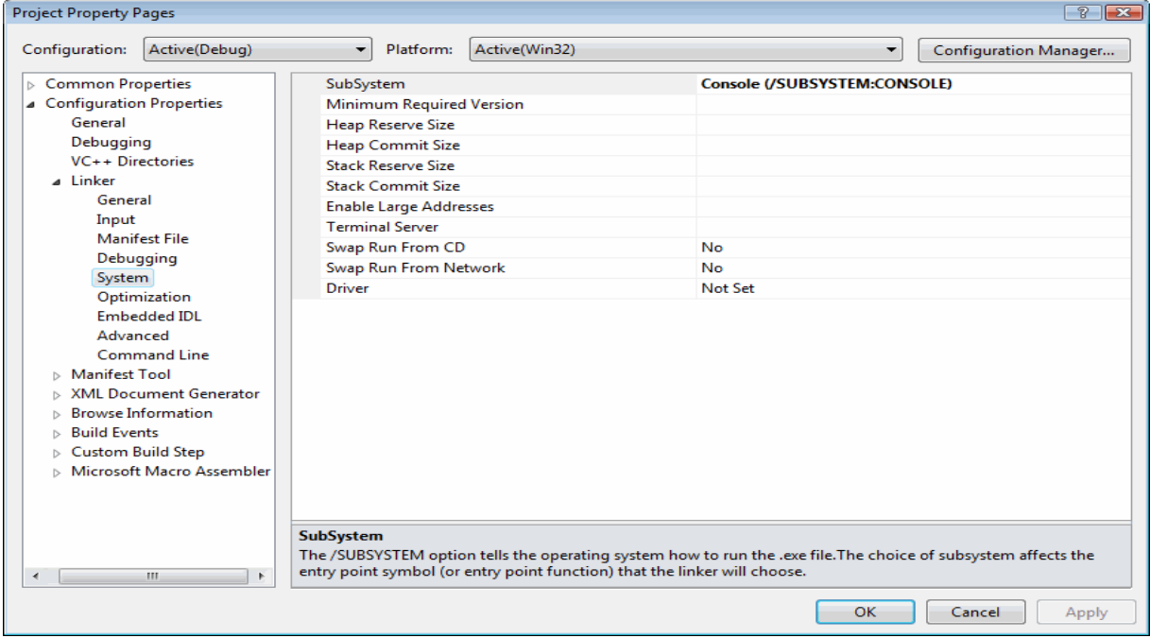

Our Visual Studio 2019 configuration for Assembly Language is complete. We can now write a sample program and run it to test our project. Open Test.asm from the solution explorer by double-clicking it. The Test.asm file will contain all the code that we write in our program. Go on and copy the following code onto your Test.asm file.

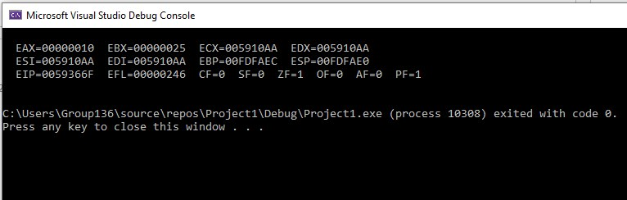TITLE My First Program (Test.asm)

INCLUDE Irvine32.inc

.code

main PROC

mov eax, 10h

mov ebx, 25h

call DumpRegs

exit

main ENDP

END main

Press **Ctrl+F5** to see the output in console window.

As we can see in the output window, the program has affected two registers eax & ebx. Let us dissect our code line by line to see what it does.

**Description of Code:**

* The first line TITLE MyFirstProgram (Test.asm) gives an optional title to our program.
* The second line INCLUDE irvine32.inc adds a reference to the include file that links your program to the Irvine library.
* The third line .code defines the beginning of the code segment (to be covered in detail later). The code segment is the segment of memory where all your code resides.
* In the fourth line, a main procedure is defined.
* The fifth and sixth lines show a mnemonic mov (to be covered in detail later) that ‘moves’ values 10h and 25h to eax and ebx, respectively. The radix h defines a hexadecimal constant.
* The lines seven and eight calls the procedure DumpRegs that outputs the current values of the registers followed by a call to windows procedure named exit that halts the program.
* The lines nine and ten mark the end of the main procedure.

# **Section 2: Debugging our program**

We have seen how to configure Visual Studio 2019 for Assembly Language and tested it with a sample program. The output of our sample program was displayed using a console window but it is usually more desirable to watch the step by step execution of our program with each line of code using breakpoints.

Let us briefly define the keywords relevant to debugging in Visual Studio and then we will cover an example for understanding.

# **Debugger**

The (Visual Studio) debugger helps us observe the run-time behavior of our program and find problems. With the debugger, we can break execution of our program to examine our code, examine and edit variables, view registers, see the instructions created from our source code, and view the memory space used by our application.

# **Breakpoint**

A breakpoint is a signal that tells the debugger to temporarily suspend execution of your program at a certain point. When execution is suspended at a breakpoint, your program is said to be in break mode.

# **Code Stepping**

One of the most common debugging procedures is stepping: executing code one line at a time. The Debug menu provides three commands for stepping through code:

* Step Into (By pressing F11)
* Step Over (By pressing F10)
* Step Out (Shift+F11)

# **Single Stepping**

To see the values of internal registers and memory variables during execution, let us use an example. Copy the following code onto your Test.asm file.k

1. Right-click on line 6 to insert a breakpoint.

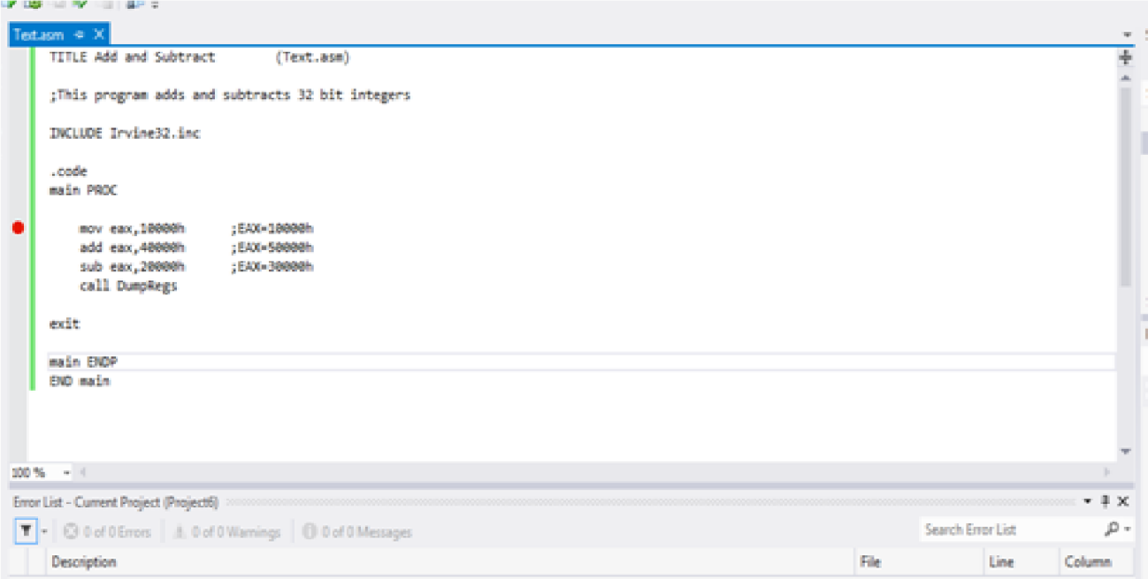

1. Click on **Debug** tab from the toolbar, select **Start Debugging** OR press **F10** to start stepping over the code.

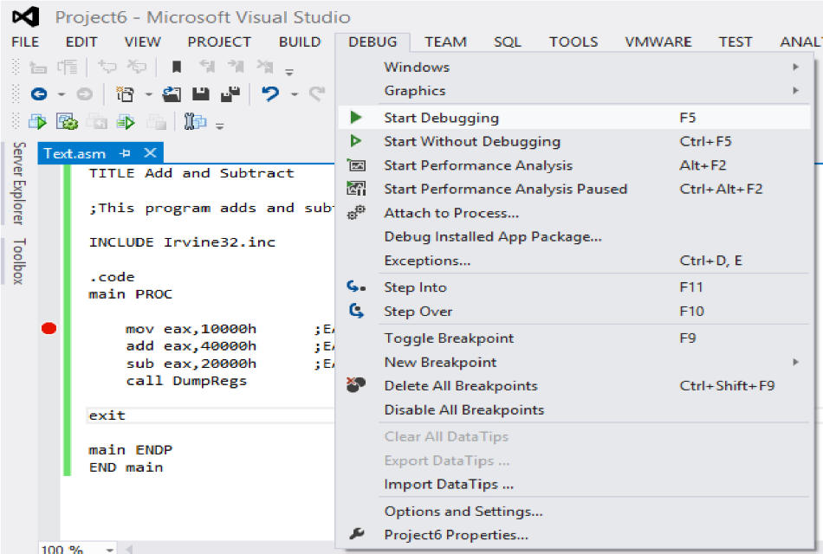

1. Click on **Debug** tab than select Windows after that open menu and select **Registers** option.

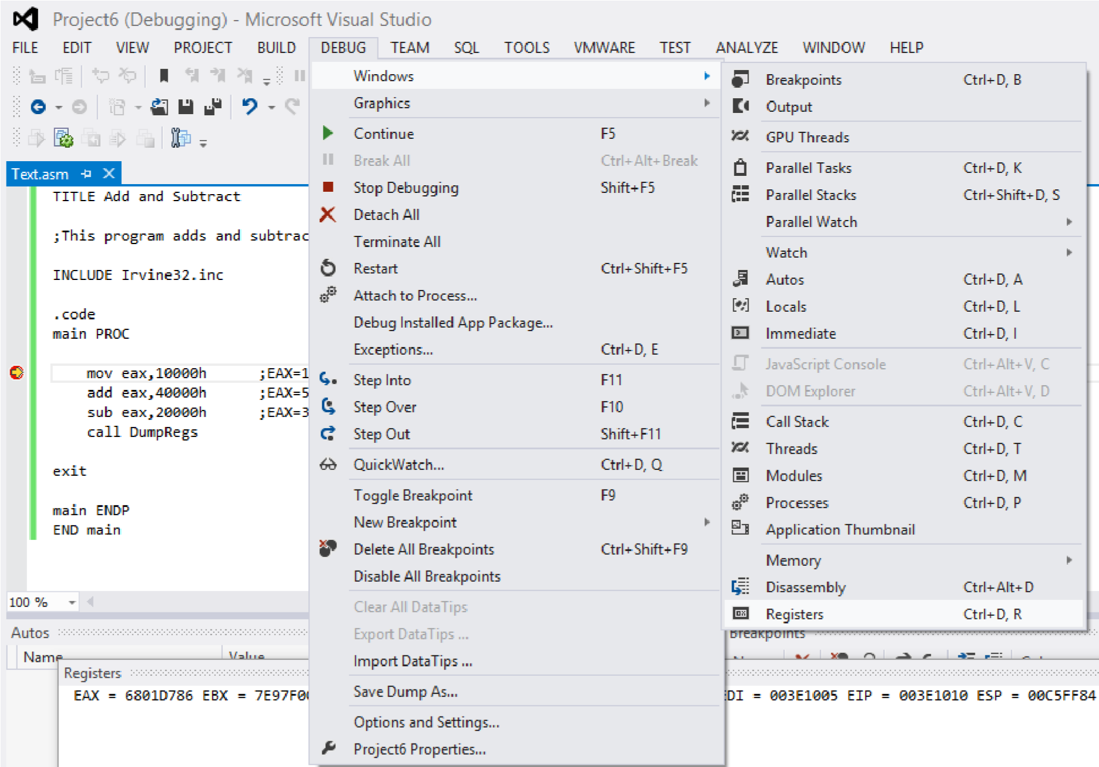

1. Breakpoint set on 1st instruction

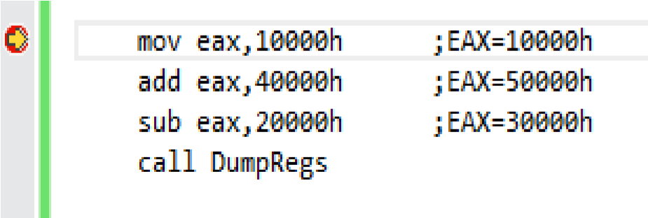

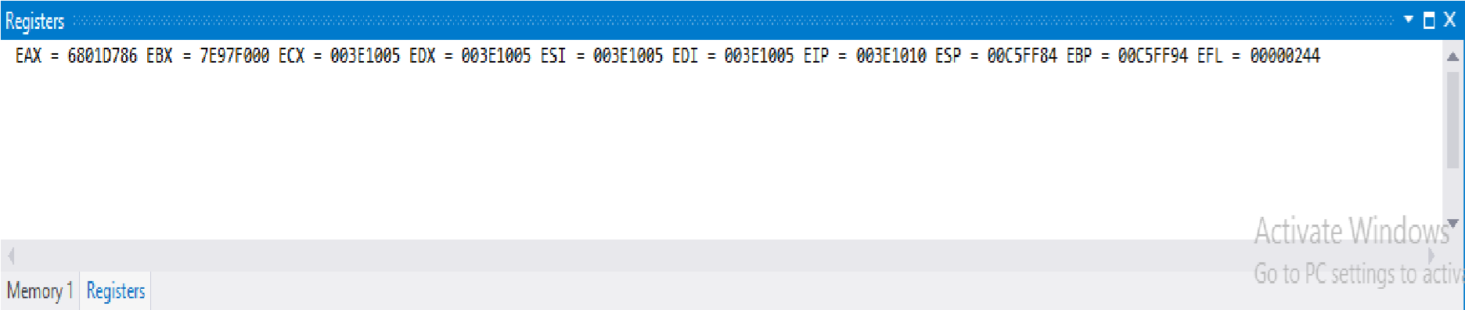

Press **F10** again to execute next line.

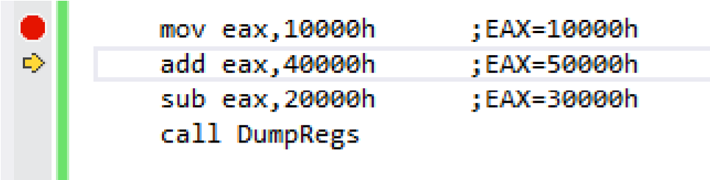



Again press **F10** key for next instruction execution.

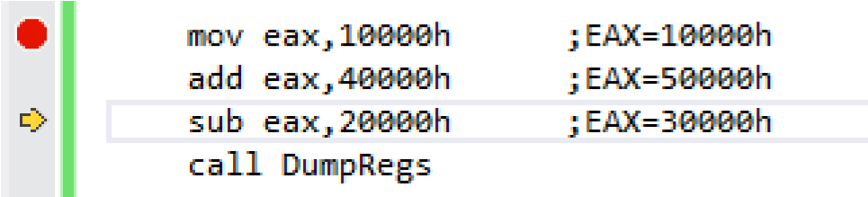



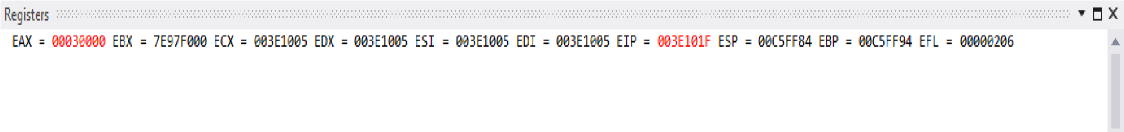Press **F10** again, the program will not terminate after executing the current instruction and as soon as it reaches the line with a call to **DumpRegs**

# **Section 2: Exercise**

1. Install Visual Studio 2019& create a new Visual C++ project for Assembly Language.
2. Configure the project using the steps show in this lab.
3. Run a test program in console window by changing the value of EAX in line 6 to 8500h.
4. Debug the below program and note down the values of all the registers after the execution of each line.

TITLE My First Program (Test.asm)

INCLUDE Irvine32.inc

.code

main PROC

mov eax, 47h

mov ebx, 39h

mov ecx, 60h

add eax, ebx

add eax, ecx

mov ebx, 85h

mov ecx, 64h

add eax, ebx

add eax, ecx

call DumpRegs

exit

main ENDP

END main